Weaver Valley CC

J9/7 – ‘Cat and Fiddle’

Hill Climb
Sunday 19th September 2021

Promoted for and on behalf of Cycling Time Trials under their Rules and Regulations

Event Secretary: Jim Williams. 463 Station Road, Winsford, Cheshire. CW7 3NF.
Williams-james10@sky.com 07891555048

Timekeepers: Tony Millington & Martin Jackson.

Headquarters: Silktown Snooker Club. Green St, Macclesfield SK10 1JQ.
There is no parking at the event HQ.

Event Car park: Global Filmmakers, Waterside House, Waterside, SK11 7HG.

Course J9/7: Start on the A537 (Buxton Road) at lamp post #30, approx 50 yards after Cottage Lane. Proceed along A537 to finish at the Cat and Fiddle Pub. (approx 6.5 miles)

Welcome to the 2021 Cat and Fiddle Hill Climb event, promoted by WVCC.

This Hill Climb event was first run in 1998. WVCC was proud to host the National Hill Climb Championships here in 2002.
THANK YOU FOR SUPPORTING OUR EVENT!
We welcome all riders of all standards, to our event. Tea and coffee only will be available at the HQ before and after the event.

Prize List: | 1st | 2nd | 3rd | “One rider – One prize” except team award  Prize list reduced in line with entries
Fastest Male | £25 | £20 | £15
Fastest Female | £25
Vet | £15
Fastest Junior | £15
Team | £ 15 each
Beating male course record | £10

Course records
Sen Male 17:46.84 Matthew Holmes 2021
Sen Female 20:47.08 Joanna Blackburn 2021
Male Vet 18:50.547 Simon Myatt 2021

THERE IS NO PARKING AT THE EVENT HQ.

PLEASE DO NOT PARK IN BAILEY COURT CARPARK NEAR THE HQ.
THIS IS A PRIVATE CARPARK AND YOUR CAR MAY BE WHEEL CLAMPED.
YOU WILL BE ENTIRELY RESPOSIBLE FOR ANY COSTS IF YOU IGNORE THIS WARNING.

PLEASE USE THE EVENT CARKPARK IT IS ONLY 3 MINS FROM THE EVENT HQ.
RIDER NOTES
- PLEASE RESPECT THE FACT THAT THE HQ IS IN A RESIDENTIAL AREA, Ensure noise is kept to a minimum. Warming up on turbo/rollers will only be allowed on the event carpark. If you choose to ignore this request, you may be DQ’d from the event.
- PLEASE note the change of HQ from previous years. The new HQ is approx ½ a mile from the start.
- PLEASE take care when cycling to and from carpark and the course [directions to start are at the end of this note]
- There will be post event tea and coffee available at £1 per cup provided by the HQ management. [our usual post event food will NOT be available].
- AS WITH ANY EVENT – IF YOU WILL NOT BE STARTING, PLEASE LET THE ORGANISER KNOW AS SOON AS POSSIBLE.
- The Risk Assessment document will be available at Signing-On but we highly recommend you read this, in advance, on the CTT District website (https://manchester.ctt.org.uk/ ) – especially those riders who are not familiar with the course (plus its ruts and potholes).
- Riding with your head down such that you do not have a good view of the road ahead is dangerous - please watch out for potholes, obstacles, and other road users.
Marshalls do not have the authority to control other road users, so please take care.
START AND FINISH
- Riders must not stop at the finish but should instead descend with care back to the headquarters to hand your number in.
COVID PRECAUTIONS and general admin
CTT has issued two PDF documents, a Covid-19 Risk Assessment and “Putting on a Cycling Time Trials Event during COVID19”. If you haven’t already read these, please download from the CTT website, and read them carefully. These are the key messages: -
- Competitors should not attend if they feel ill in ANY way especially if they or family members have any Covid19 symptoms.
- There are men’s and women’s toilets at the HQ, one in – one out, wear a mask and queue 2 metres apart if possible. Users to apply hand sanitizer on entry.
- There are no changing facilities at the HQ, please come dressed ready to ride.
- Numbers and signing on will be at the HQ from 0900. Please wear the arm number on the LEFT arm.
- Avoid the use of “U” turns. A “U” turn in the vicinity of the start will lead to disqualification from the event and any competitor seen infringing traffic regulations will be liable to disqualification and may be reported to the District Committee for further disciplinary action.
- There is to be No parking at the start.
- No more than five riders are allowed to queue at the start, so time your arrival accordingly maintain a 2m gap if possible, Do not block the pavement when waiting at the start. Always ensure other pedestrians can pass safely.
- Do not leave any clothing, bottles etc at the start.
- After passing the finish continue for 300m to an unclassified road on the left where it will be safer to stop to turn around. There will be NO CATCHERS at the finish.
- No parking at the Cat & Fiddle car park. We do not have explicit permission to park here and if you choose to do so, it is entirely at your own risk.
- Please bring your own post-ride recovery snacks and drinks. However, the HQ Management will offer tea and coffee @ £1/cup.
- There is no public display Results Board at the HQ, results will be available on the CTT website after the event with award winners notified by post

- You must return your numbers to the HQ AND SIGN OUT at the end of the event then please go home and do not congregate.
- Please park at the event carpark at Global Filmmakers, Waterside House, Waterside, SK11 7HG
- A competitor overtaking another must pass without receiving or giving shelter. The onus of avoiding company riding shall be upon the rider overtaken. (CTT Reg 21).
- Riders must exercise care at all times.
- Observers will be present at the event.
- Do not Approach, Disturb or Obstruct the timekeeper at the finish.

PLEASE DO NOT PARK IN BAILEY COURT CARPARK NEAR THE HQ.
THIS IS A PRIVATE CARPARK AND YOUR CAR MAY BE CLAMPED.
YOU WILL BE ENTIRELY RESPOSIBLE FOR ANY COST IF YOU IGNORE THIS WARNING.

IN THE INTERESTS OF YOUR OWN SAFETY
HELMETS
Cycling Time Trials and the event promoters strongly advised for your own safety that you wear a hard-shell helmet that meets an internationally accepted safety standard.
All competitors who will be under the age of 19 on 31st December of this year MUST wear a properly affixed helmet of hard/soft shell construction.
For these riders, a helmet is required (CTT Reg 15), instead of just strongly advised.
REAR LIGHT
CTT Reg 14(i) No competitor shall be permitted to start either a Type A or Type B event unless such competitor has affixed to the rear of their machine a working rear red light, either flashing or constant, that is illuminated and in a position that is clearly visible to other road users.

Directions from Event carpark to HQ

Turn left from carpark onto Waterside.
Left onto Windmill St then Immediately Left onto Knight St.
At the end of Knight St, turn Left onto Bank St. which becomes Tuncock St.
Straight on at the X roads with Jodrell St, then straight on at the junction with Brook St onto Thorneycroft St
This becomes Glegg St, stay on Glegg St until junction with Green St where Right, Silktown Snooker [Event HQ] in on the left.

Directions from the HQ to the Start.
Turn left out of HQ along to the end of Green St to A537 where Right onto the A537 [with care]
Proceed on the A537, the Start is approx. 0.3 miles on the Left.

PLEASE DO NOT PARK IN BAILEY COURT CARPARK NEAR THE HQ.
THIS IS A PRIVATE CARPARK AND YOUR CAR MAY BE CLAMPED.
YOU WILL BE ENTIRELY RESPOSIBLE FOR ANY COST IF YOU IGNORE THIS WARNING.

Location of event carpark

E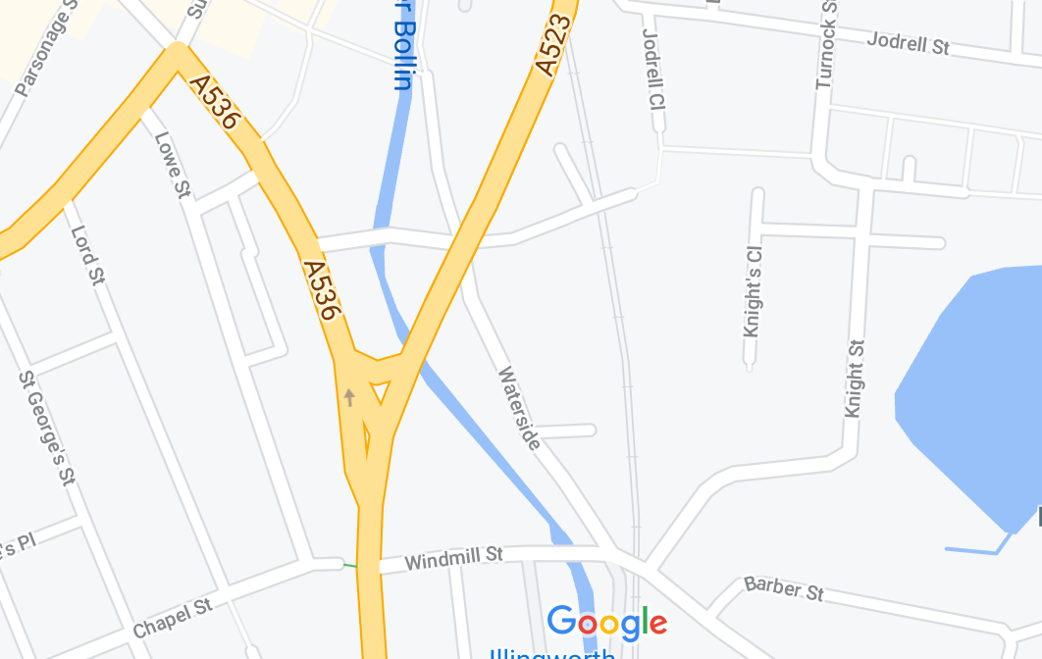
To HQ
To HQ
Event Carpark
L To HQ

HQ
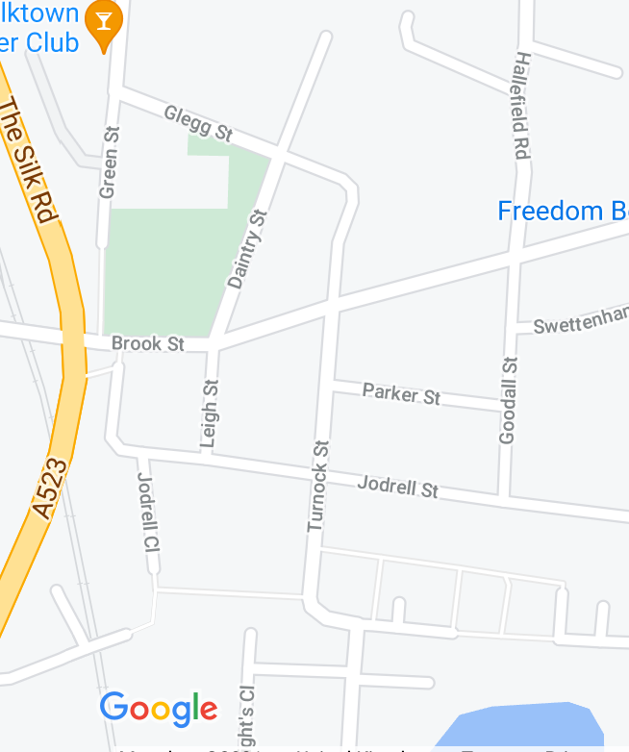
To HQ
To HQ
To HQ

From HQ to Start

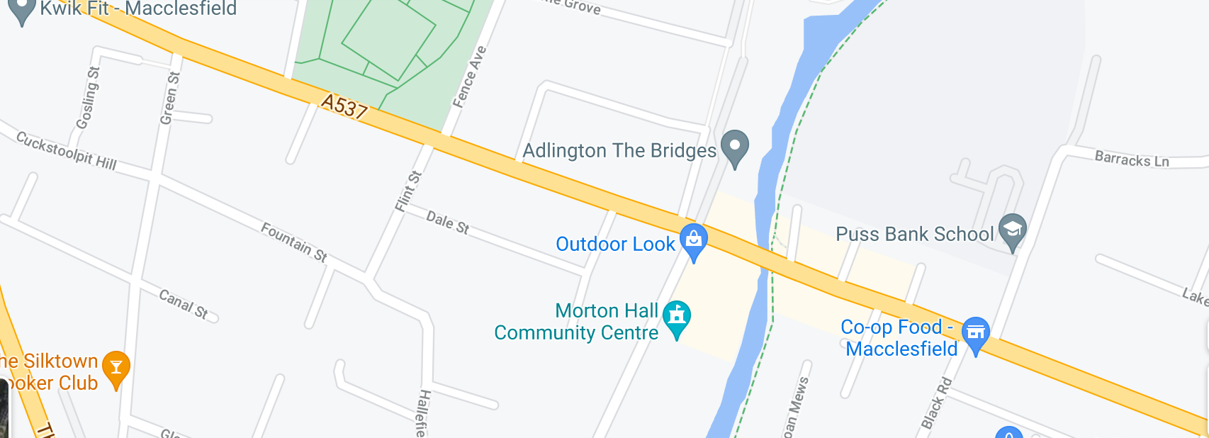
To Start

HQ

Start

PLEASE DO NOT PARK IN BAILEY COURT CARPARK NEAR THE HQ.
THIS IS A PRIVATE CARPARK AND YOUR CAR MAY BE CLAMPED.
YOU WILL BE ENTIRELY RESPOSIBLE FOR ANY COSTS IF YOU IGNORE THIS WARNING.

No | Rider |  | Club | Category | Age | Start Time
17 | ALICE | LARKIN | Glossop Kinder Velo CC | FV | 47 | 10:17
18 | DIANA | BITE | The Racing Chance Foundation | F | 26 | 10:18
19 | FAYE | SHARPLEY | Holmes Chapel Velo | F | 37 | 10:19
20 | SARAH | SODEN | Leicester Forest CC | FV | 57 | 10:20
21 | JESSICA | EVANS | ASSOS Speed Club UK | FV | 42 | 10:21
22 | MONICA | GREENWOOD | Macclesfield Wheelers | F | 32 | 10:22
24 | JOHN | KEEN | Weaver Valley CC | MV | 56 | 10:24
25 | JAMES | BRAYFORD | Lyme Racing Club | M | 23 | 10:25
26 | ALEX | RAYNARD | Lifting Gear Products/Cycles in Motion | M | 21 | 10:26
27 | MATTHEW | HEATH | Weaver Valley CC | M | 39 | 10:27
28 | MICHAEL | STANLEY | North Wirral Velo | MV | 60 | 10:28
29 | ANDREW | BRADBURY | Congleton CC | M | 34 | 10:29
30 | BIRMA | BOWDEN | Macclesfield Wheelers | M | 33 | 10:30
31 | LAURENCE | FRYER-TAYLOR | OVB | M | 29 | 10:31
32 | SAM | MARSHALL | Trash Mile | M | 24 | 10:32
33 | SAM | CLARK | Buxton/Sett Cycles | MV | 41 | 10:33
34 | ROBERT | ELSONE | Manchester Wheelers | MV | 57 | 10:34
35 | DAN | EVANS | ASSOS Speed Club UK | MV | 40 | 10:35
36 | THIJS | GEURTS | Macclesfield Wheelers | MV | 47 | 10:36
37 | DANIEL | STEVENS | Liverpool Century RC | M | 31 | 10:37
38 | THOMAS | TURTON | Seamons CC | M | 30 | 10:38
39 | PAUL | ROBINSON | Lyme Racing Club | MV | 58 | 10:39
40 | ALISTAIR | RIBBANDS | Manchester Wheelers | M | 38 | 10:40
41 | TIMOTHY | LANE | JRC Shutt Ridley RT | MJ | 17 | 10:41
42 | WILLIAM | ADAMS | Manchester Bicycle Club | M | 26 | 10:42
43 | CHRIS | BARLOW | Holmes Chapel Velo | M | 28 | 10:43
44 | CHRIS | TACKABERRY | Islington Cycling Club | MV | 54 | 10:44
45 | MARTYN | STEWART | East Lancashire RC | M | 35 | 10:45
46 | ALEX | WHITMORE | Ratae RC | M | 29 | 10:46
47 | JOEL | BARNETT | Belper BC | M | 38 | 10:47
48 | DALE | WILKES | Mansfield Road Club | MV | 40 | 10:48
49 | ED | MOSS | Beacon Roads CC | MV | 51 | 10:49
50 | JONATHAN | MORRIS | AeroCoach | M | 29 | 10:50
51 | JAMES | RUSSELL | Macclesfield Wheelers | MV | 59 | 10:51
52 | PAUL | WHITTAKER | Stockport Clarion CC | MV | 50 | 10:52
53 | LEWIS | TAYLOR | Kingston Wheelers CC | MV | 46 | 10:53
54 | CHRIS | WILCOX | Lyme Racing Club | MV | 58 | 10:54
55 | ALEX | FOSTER | Innovation Racing | MJ | 16 | 10:55
56 | TONY | COPE | Leek CC-Den Engel Belgian Bar | MV | 48 | 10:56
57 | ADRIAN | THORPE | Fibrax Wrexham RC | MV | 50 | 10:57
58 | PAUL | STUPPLES | Wigan Wheelers CC | MV | 54 | 10:58
59 | CHRIS | DYKE | Rutland Cycling Club | M | 38 | 10:59
60 | BEN | NORBURY | Congleton CC | M | 37 | 11:00

